What are the permissions assigned to the file after the execution of the following commands?

a. $chmod 700 abc

b. $chmod u+rwx,go-rwx file1 file2

c. $chmod 536 xyz

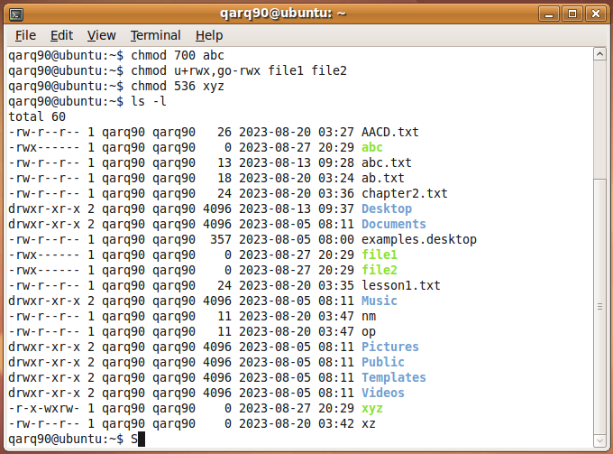

Create new files pqr and pqr1, perform the commands:

a. $chmod ugo=r pqr

b. $chmod ugo+r pqr1

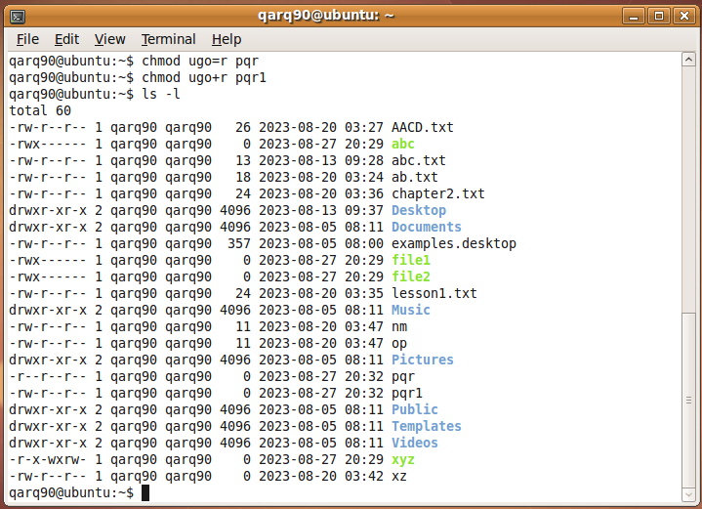

Assign read and write permission for the owner, write permission for the group and execute permission for others using octal method for file ‘mfile’.

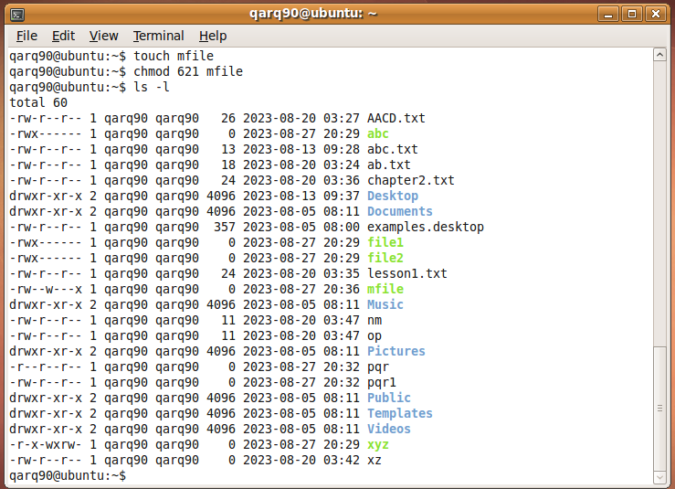

Write commands to assign following permissions to the file OSY using octal method.

a. -----------

b. –rw-r-xr--

c. -r-xr-xr-x

